Data Structure and Algorithm

Laboratory Activity No. 3

Translating Algorithm to Program

|  |  |
| --- | --- |
| *Submitted by:* | *Instructor:* |
| Polestico,Paul Justine D. | Engr. Maria Rizette H. Sayo |

August, 02, 2025

# Objectives

Introduction

Data structure is a systematic way of organizing and accessing data, and an algorithm is a step-by-step procedure for performing some tasks in a finite amount of time. These concepts are central to computing, but to be able to classify some data structures and algorithms as “good,” we must have precise ways of analyzing them.

This laboratory activity aims to implement the principles and techniques in:

* Writing a well-structured procedure in programming
* Writing algorithm that best suits to solve computing problems
* Writing an efficient Python program from translated algorithms

# Methods

• Design an algorithm and the corresponding flowchart (Note: You may use LucidChart or any application) for adding the test scores as given below if the number is even: 26,49,98,87,62,75

• Translate the algorithm to a Python program (using Google Colab)

• Save your source codes to GitHub

# Results

Algorithm:

* + 1. Start
    2. Initialize sum = 0
    3. Create a list of scores: [26,49,98,87,62,75]
    4. For each score in the list:

1. If score % 2 == 0:
2. i. Add score to sum
   * 1. After loop ends, display sum
     2. End

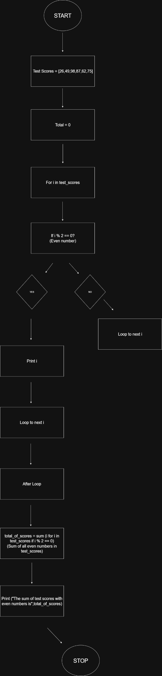Flowchart:

Figure 1 Flowchart of program

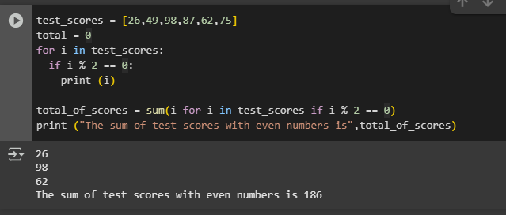

Figure 2 Program

The program uses the “i % 2 == 0” condition to check if the test scores have even numbers. Once all even numbers are displayed individually, they are then added to find the sum of all test scores with even numbers.

Conclusion

**The purpose of an algorithm** is to provide a clear, step-by-step set of instructions that a computer can follow to solve a specific problem. Being capable of translating an algorithm into a working program is important because it demonstrates how planning and problem-solving are applied in actual code. This process bridges the gap between abstract logic and practical implementation, making it easier to communicate, develop, and execute ideas through computer programming.

**References**

[1] Co Arthur O.. “University of Caloocan City Computer Engineering Department Honor Code,” UCC-CpE Departmental Policies, 2020.

[2] GeeksforGeeks, “Print all even numbers in a range Python,” *GeeksforGeeks*, Jul. 11, 2025. <https://www.geeksforgeeks.org/python/python-program-to-print-all-even-numbers-in-a-range/> (Accessed August 2, 2025)

Please refer to this link:

<https://github.com/PaulJustinePolestico/CPE-201L-DSA-2-A/blob/main/DSA%20Laboratory%20Activities/Laboratory%20Activity%20%233/DSA_Laboratory_Activity_3.ipynb>